|  |  |  |  |  |  |
| --- | --- | --- | --- | --- | --- |
| Date | 30-Nov-22 | | | Tester Name | Natalia Kokhman |
| Environment | Penfax - Test | | | Login used |  |
| Operating System | Windows | Version: | Update: | | |
| Software Used | Edge | Version: | Update: | | |
| Select Software | Version: | Update: | | |
| Release version | 22.4.1 | | | | |
| Title | E5.03 Terminate someone with 2 active employers. Only terminate 1 employer | | | | |
| Test Type | Regression | | | | |
| Test Scenario | E5.03 Terminate someone with 2 active employers. Only terminate 1 employer | | | | |
|  |  | | | | |
| Expected Results | 1 of the employments should be ended with the End Reason Termination.  Member Status should remain Active.  Termination Option Letter should not be generated. | | | | |
| Pass/Fail | Pass | | | JIRA# | N/A |

Describe your steps with screenshots:

1. Bring up active member who has active employment with 2 employers.

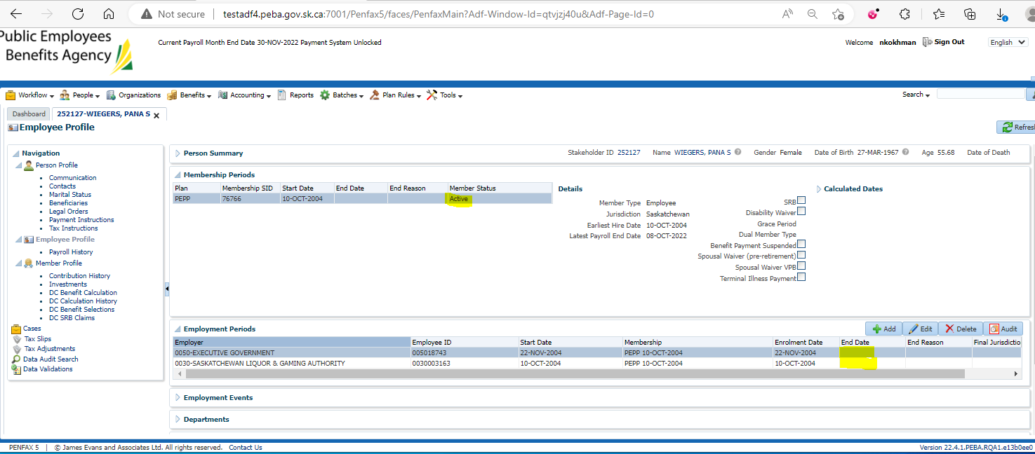

1. Log into DCT to terminate member from 1 employment. Select an Employer from the dropdown and click on Import Data. Upload a CSV file for Termination. Validate, approve and process the file.

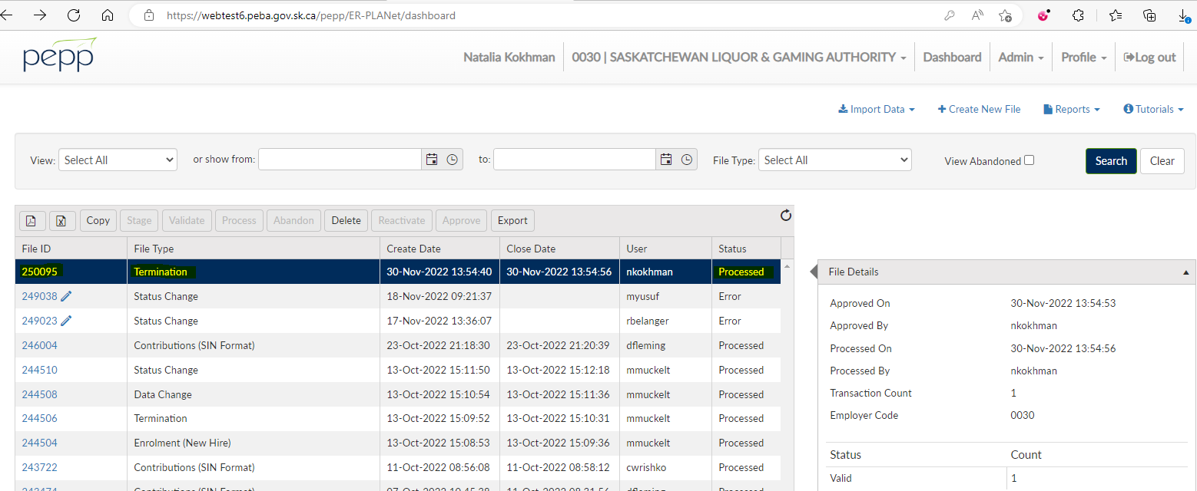

1. Go to Penfax and then Data Posting Batches. Click on Data Posting Batch ID, go to Pending tab and validate and then submit the transaction records.

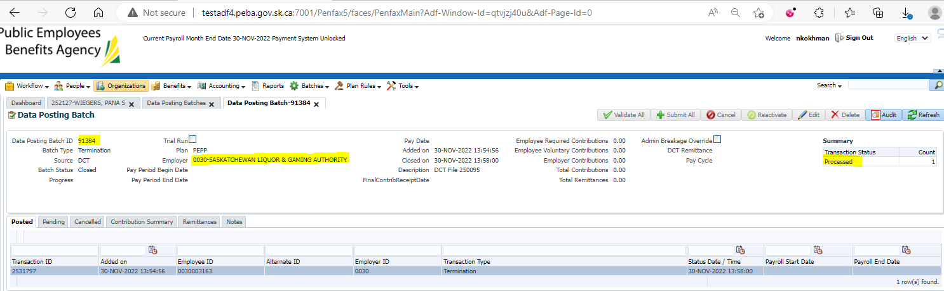

1. Once the data posting batch is submitted, bring up your member.
2. Go to Employee Profile -> Employment Periods, 1 of the employment should now have the End Date and the Termination as the End Reason.

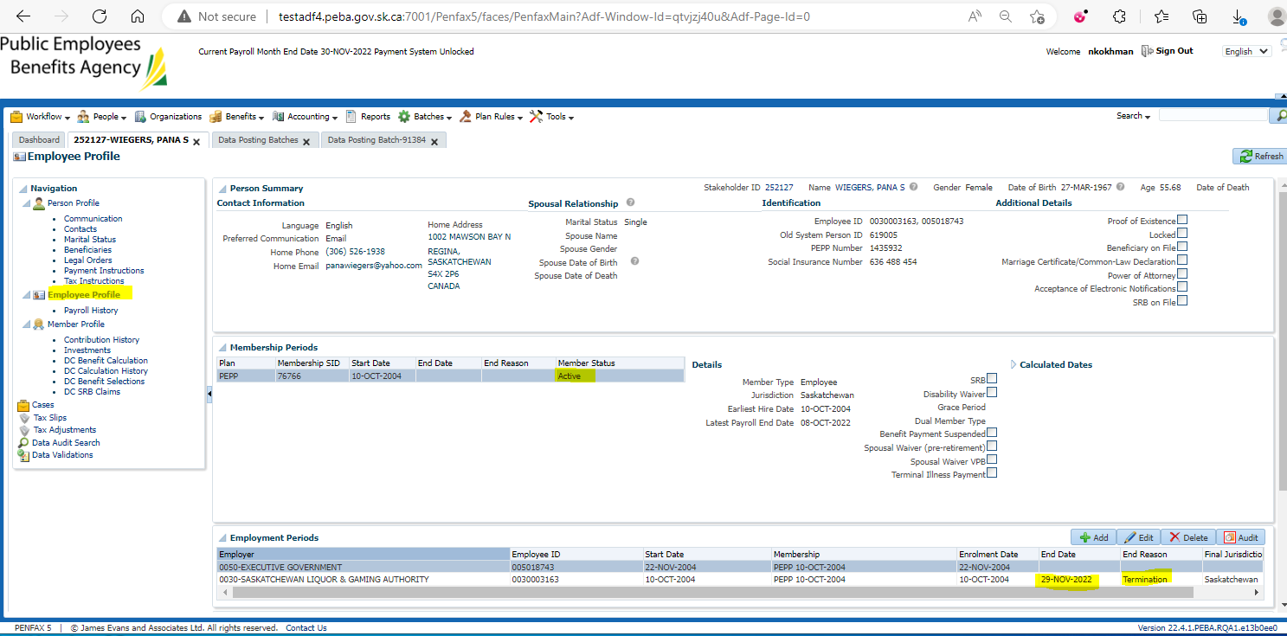

1. Go to Member Profile. Member Status should be active as member is still employed with 1 employer.

But under Employment Periods, there should be an end date available for the employment from which member got terminated.

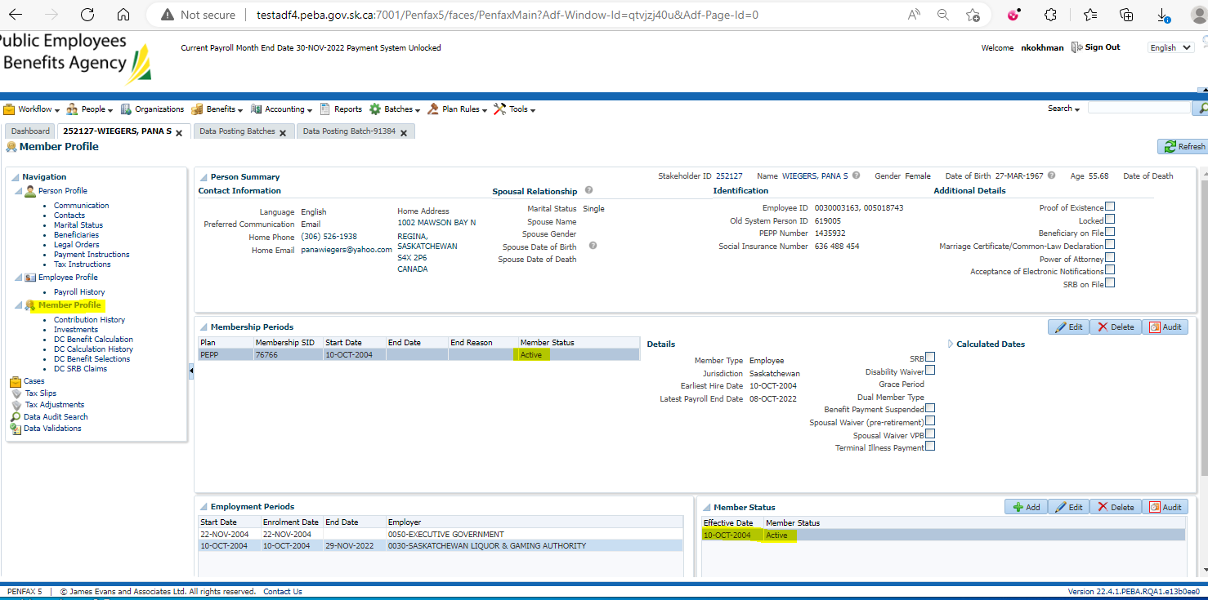

1. Go to Person Profile -> Communication -> Outbound Documents -> Termination Option Letter should not have been generated as member is still active in PEPP.

